**Amyvid Project SetUp Guide:**

**1) Jdk path set in environment variable**

a) JAVA_HOME eg: C:\Program Files\Java\jdk1.8.0_45

b)path %JAVA_HOME%/bin

2) **Setup of STS/Eclipse Id on Local machine using exe setup**

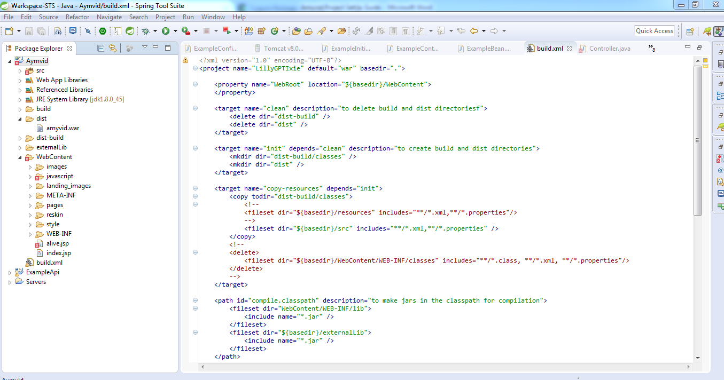

3) **Take a checkout application from SVN given location** :

i) We can create a simple java project and point to SVN checkout project of locally.

4).**Apache tomcat setup on local machine**.

**Debug the APPLICATION ON LOCAL SERVER**:

We replace comment code with second line .

#exec "$PRGDIR"/"$EXECUTABLE" start "$@"

exec "$PRGDIR"/"$EXECUTABLE" jpda start "$@"

5)**Execute the Url on browser**

http://localhost:8080/amyvid